Class 13 - Content – Comparisons

Objective: making comparisons

Problem 1: In our social interaction, sometimes it is common to make comparisons during conversations. So, to practice this sort of situation you need to prepare a dialogue with one or two partners using one of these topics. You cannot use the same adjective more than twice. (2,0 pontos)



(from <https://unsplash.com/pt-br/fotografias/maquina-de-escrever-cinza-e-macbook-1F4MukO0UNg>)

**1 – Cultural contrasts**: you can compare the cultural norms and traditions of two different countries, you can discuss how cultural differences impact daily life, communication styles, and celebrations.

**2 – Technology evolution**: you can compare the evolution of technology from the past to the present, you can discuss how technological advancements have changed the way people work, communicate, and live.

**3 – Generational differences**: you can compare the values, attitudes, and lifestyles of different generations, you can discuss how societal changes have influenced each generation.

**4 – Educational systems**: you can compare the educational systems of two countries or time periods; you can discuss the strengths and weaknesses of each system and how they prepare individuals for the future.

**5 – Environmental practices**: you can compare the environmental practices and awareness in different communities or countries, you can discuss the impact of these practices on sustainability and the natural world.

**6 – Workplace cultures**: you can compare the culture of two different organizations or industries, you can discuss factors such as communication styles, leadership approaches, and work-life balance.

**7 – Personal growth**: you can compare personal growth of two individuals, you can discuss the challenges faced, lessons learned, and the impact on their lives.

**8 – Social media platforms**: you can compare popular social media platforms, discussing their features, purposes, and impacts on society.

To help you to develop the proposed task you can follow these steps or choose your own way:



(from <https://www.istockphoto.com/br/search/2/image-film?phrase=people+talking>)

1-Listening: listen to this conversation and do the exercise (from Business Result Pre-Intermediate, by Grant & Hudson, OUP, page 38).



1.1– Petr and Ludmila work for the Customer Service Department of an Internet provider company. Listen to Petr reporting the results of a recent survey to Ludmila and answer these questions:

1- Which age group and sex use the Internet most?

____________________________________________________________________________________________________________________________________________

2-What are the two most popular activities?

____________________________________________________________________________________________________________________________________________

3-Where do they usually log on?

___________________________________________________________________________________________________________________________________________

4-Why don’t they use the Internet more?

___________________________________________________________________________________________________________________________________________

5-What do they buy the most online?

___________________________________________________________________________________________________________________________________________

Class 14 - Content – Comparisons

2 – Language structure: Comparative and Superlative of adjectives.

To understand and to use the comparative and superlative of adjectives you can watch the suggested video, study the explanation that follows, or search for another material about the topic.

2.1- Suggested video:

<https://www.youtube.com/watch?v=wwLaiF_bVpI>

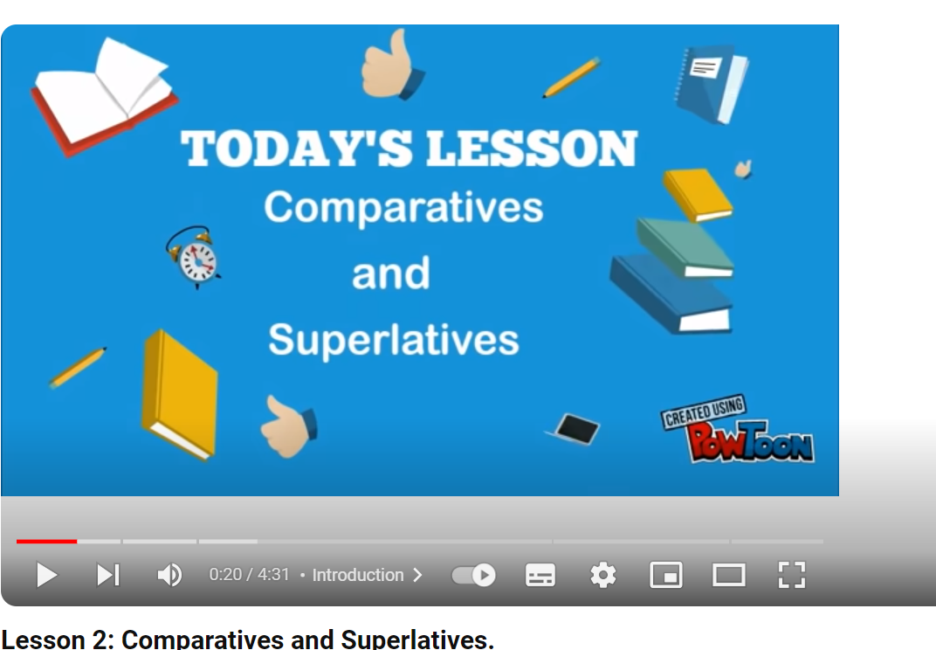

2.2 - Explanation:

|  |  |
| --- | --- |
| COMPARATIVE OF ADJECTIVES | |
| ADJECTIVES OF 1 OR 2 SYLLABLES | |
| Base form | Comparative -ER + THAN |
| Cold | coldER THAN  Campos do Jordão is colder than Ubatuba. |
| Fast | fastER THAN  Travelling by plane is faster than by car. |
| Clever | cleverER THAN  Joe is cleverer than George. |

|  |  |
| --- | --- |
| COMPARATIVE OF ADJECTIVES | |
| ADJECTIVES OF 2, 3 OR MORE SYLLABLES | |
| Base form | Comparative – MORE ---- THAN |
| expensive | MORE expensive THAN  A Ferrari car is more expensive than a Honda car. |
| beautiful | MORE beautiful THAN  “Parque da Cidade” is more beautiful than “Parque Santos Dumont”. |

Class 15 - Content – Comparisons

Objective: making comparisons

|  |  |
| --- | --- |
| SUPERLATIVE OF ADJECTIVES | |
| ADJECTIVES OF 1 OR 2 SYLLABLES | |
| Base form | Comparative – THE -EST |
| Cold | THE coldEST  Campos do Jordão is the coldest city in São Paulo state. |
| Fast | THE fastEST  Travelling by plane is the fastest way. |
| Clever | THE cleverEST  Joe is the cleverest in his department. |

|  |  |
| --- | --- |
| SUPERLATIVE OF ADJECTIVES | |
| ADJECTIVES OF 2, 3 OR MORE SYLLABLES | |
| Base form | Comparative – THE MOST |
| expensive | THE MOST expensive  Ferrari is one of the most expensive cars. |
| beautiful | THE MOST beautiful  “Parque da Cidade” is the most beautiful one in São José dos Campos. |

|  |  |  |
| --- | --- | --- |
| COMPARATIVE AND SUPERLATIVE OF ADJECTIVES | | |
| RULES FOR ADJECTIVES OF 1 OR 2 SYLLABLES | | |
| Base form | Comparative | Superlative |
| Wide | widER THAN | THE widEST |
| Busy | busIER THAN | THE busIEST |
| Big | biGGER THAN | THE biGGEST |

|  |  |  |
| --- | --- | --- |
| IRREGULAR COMPARATIVE AND SUPERLATIVE | | |
| Adjective | Comparative | Superlative |
| good | BETTER THAN | THE BEST |
| bad | WORSE THAN | THE WORST |
| far | FARTHER/FURTHER THAN | THE FARTHEST/FURTHEST |
| little | LESS THAN | THE LEAST |
| many | MORE THAN | THE MOST |

Class 16 - Content – Comparisons

Objective: making comparisons

3-Exercises: Complete the sentences with a correct comparative or superlative of the adjective in parentheses.

1-The journey from São José dos Campos to Presidente Prudente is ________________ (long) than to Rio de Janeiro.

2- I am _________________ (happy) with my new job than with my old one.

3- Some of ________________ (intelligent) students have studied at this faculty.

4- There isn’t a ______________ (pleasant) time than a walk along the beach.

5- My sister has a _____________ (tidy) bedroom than me.

6- I think Chinese is ______________ (difficult) language in the world.

7- Who is _____________ (shy) person in your family?

8- December and January are usually _____________ (hot) months of the year.

9- Which of the two supermarkets do you think has ____________ (wide) range of products?

10- It’s becoming ________________ (hard) to attract new clients, we need to change our strategy.

3.1 - Do these online exercises.

<https://www.ego4u.com/en/cram-up/grammar/adjectives-adverbs/adjectives/exercises>

<https://www.grammar.cl/Games/Comparatives_Superlatives.htm>

<https://elt.oup.com/student/solutions/preint/grammar/grammar_04_012e?cc=br&selLanguage=pt>

Class 17 - Content – Comparisons

Objective: making comparisons



(from <https://www.istockphoto.com/br/search/2/image-film?phrase=people+talking>)

4 – Speaking: Ask and answer these questions:

**1-Which is harder, math or English? Why?**

**2-Does technology make the world better or worse? Why?**

**3-Are you more creative now or when you were in elementary school? Explain.**

**4-Is it better to study English in class or online? Why?**

**5-If you own a business, is it more important to be good with numbers or be creative? Why?**

**6-Do you want the development of new technology to go faster or slower? Why?**

7-What would you like to be better at than anyone else in the world? Why?

8-What is healthier: eating good food or getting lots of exercises? Why?

9-What do you think is the best job in the world? Why?

10-Who is the most creative person in your family?

11-Where is the best place to visit in your city? What can you do there?

12-What is the best series you have seen? Why?

13-What country is the best to live in? Why?

14- Do you think it’s easier to make friends in person or online?

15- What do you think is more difficult, learning a new language or a musical instrument?

16- Which is more enjoyable, watching a movie at home or going to the cinema?

17- Do you think it’s easier to make a decision alone or in a group?

18- Is it more productive to work from home or in an office?

19- Do you think I’s more advantageous to have higher education or to gain work experience?

Class 18 - Content – Comparisons

Objective: making comparisons



(from <https://www.freepik.com/free-photos-vectors/student-activities>)

5- Speaking – Prepare the dialogue suggested in problem 1.

Class 19 - Content – Comparisons

Objective: making comparisons

5- Speaking – Prepare the dialogue suggested in problem 1.

Class 20 - Content – Comparisons

Objective: making comparisons



(from <https://unsplash.com/pt-br/s/fotografias/group-presentation>)

6 – Dialogue: presentation of the dialogue suggested in problem 1. (2,0 pontos)

Class 21 - Content – Comparisons

Objective: making comparisons

6 – Dialogue: presentation of the dialogue suggested in problem 1. (2,0 pontos)